# **Compare 2 model (with / without random slope)**

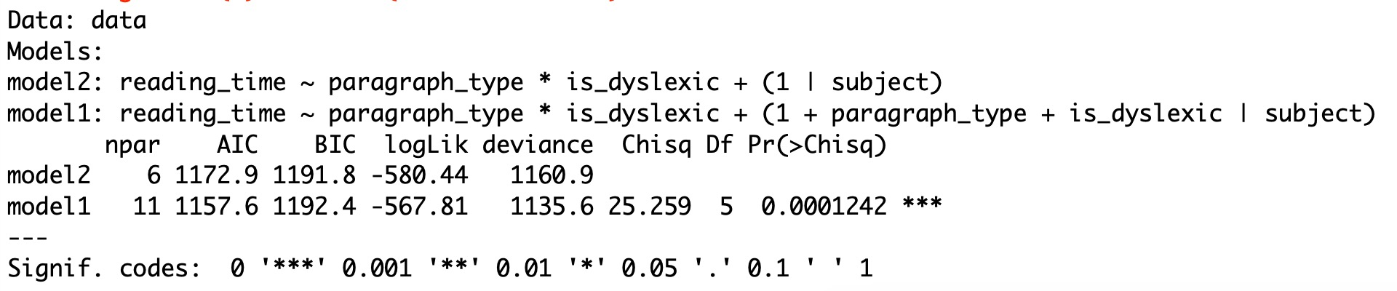

In this case, model1 with 15 parameters has a lower AIC and BIC compared to model2, which would typically indicate that model1 fits the data better.

The p-value indicates the significance of the difference between the two models. A value less than 0.05 suggests a significant difference, meaning that the more complex model (model1) significantly better fits the data than the simpler model (model2) does.

# **Results regarding reading_time**

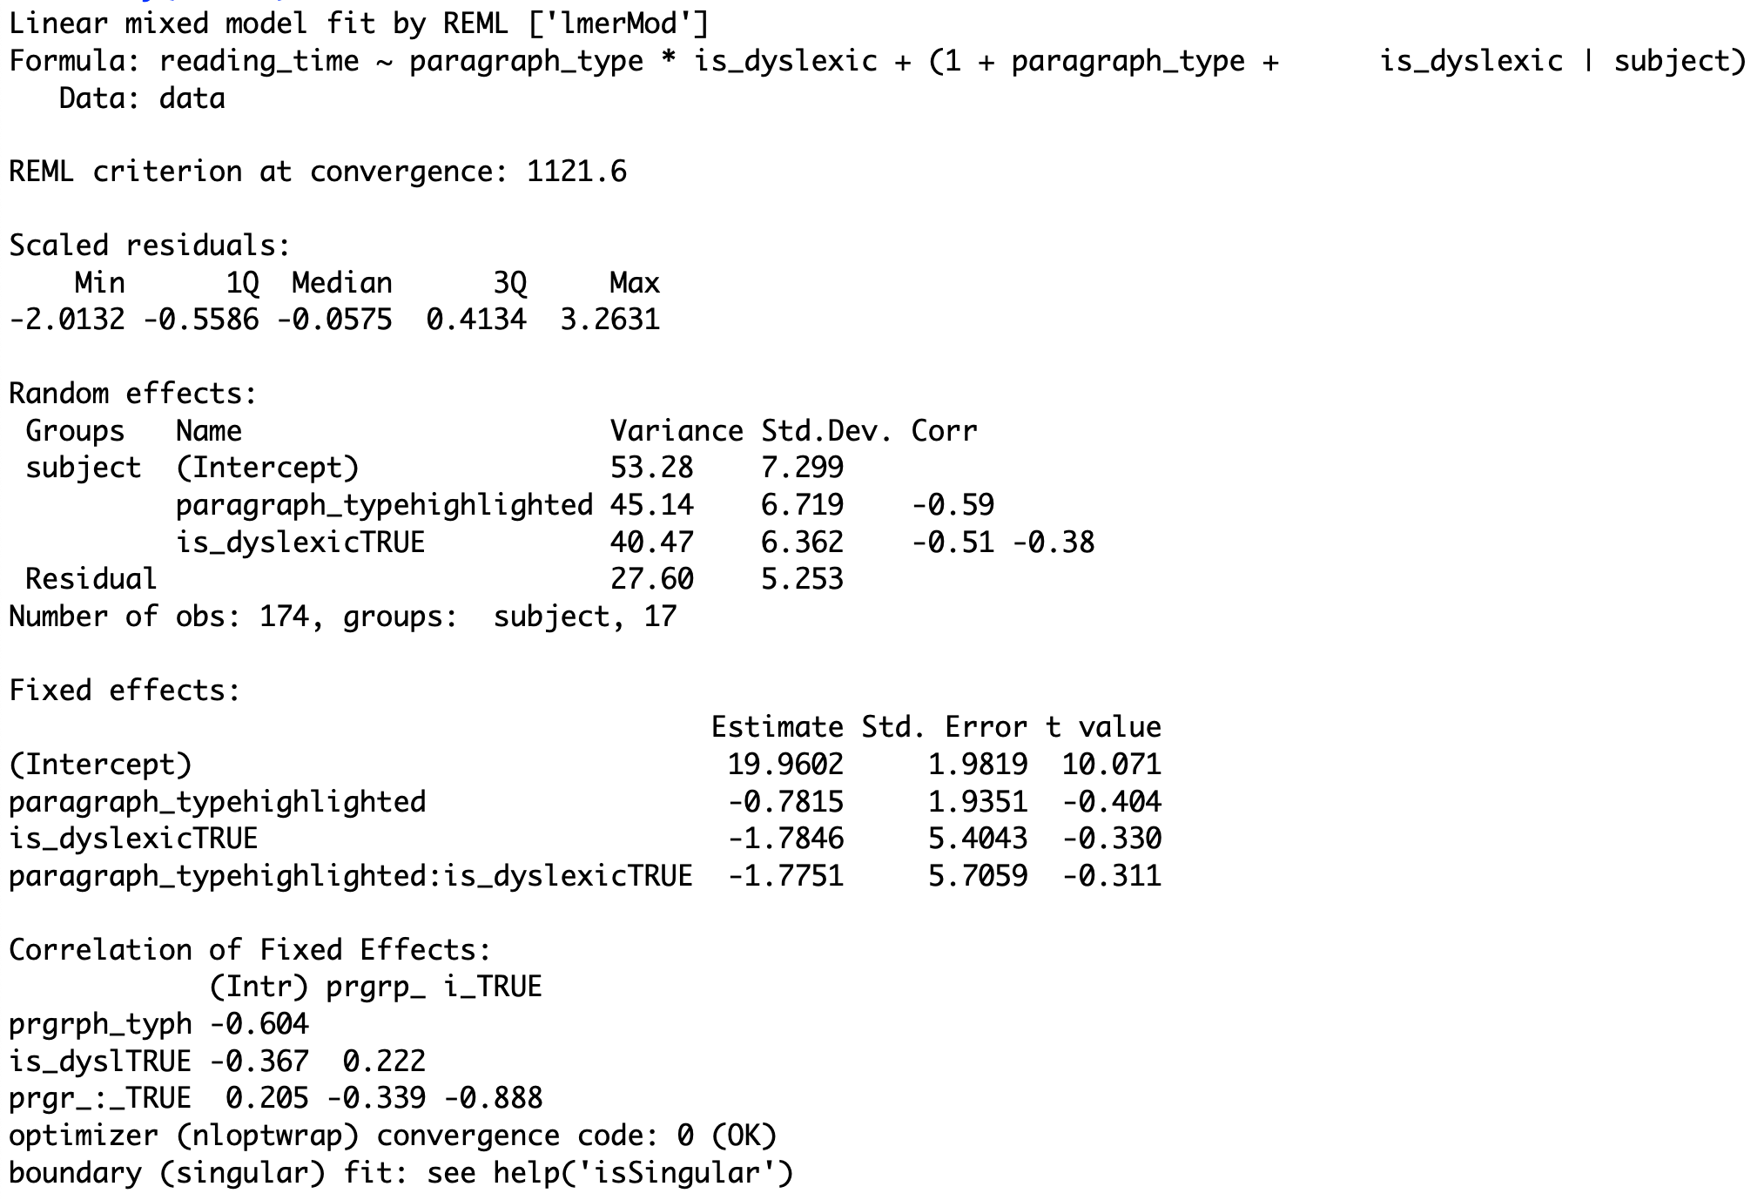

1. The impact of highlighted paragraph type on reading time is not significant (-0.7815),
2. The impact of being dyslexic on reading time is also not significant (-1.7846),
3. The interaction impact between highlighted paragraph type and dyslexia on reading time is not significant (-1.7751)



# **Results regarding error rate.**

Acc_model <- glmer(correct_response ~ paragraph_type * is_dyslexic + (1|subject),

data = data, family = "binomial")

